1. What are the two values of the Boolean data type? How do you write them?

Ans = true and false. We write them as True , False

1. What are the three different types of Boolean operators?

Ans = AND , OR , NOT

4.What are the values of the following expressions?

(5> 4) and (3 == 5) = false

not (5 > 4) = false

(5 > 4) or (3 == 5) = true

not ((5> 4) or (3 == 5)) = false

(True and True) and (True == False) = false

(not False) or (not True) = true

1. What are the six comparison operators?

Ans = != , ==,>,<,<=,>=

1. How do you tell the difference between the equal to and assignment operators?Describe a

condition and when you would use one.

Ans = equal to ( = ) , assignment( ==)

a = 5 (can be changed) , a== 5(a must be 5)

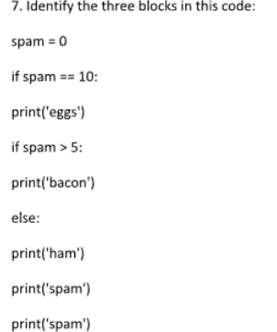

Ans = block 1 spam = 0

Block 2 = if statement

Block 3= if else statement

8. Write code that prints Hello if 1 is stored in spam, prints Howdy if 2 is stored in spam, and prints

Greetings! if anything else is stored in spam.

spam = int(input("Enter a value for spam: "))

if spam == 1:

print("Hello")

elif spam == 2:

print("Howdy")

else:

print("Greetings!")

1. If your programme is stuck in an endless loop, what keys you’ll press? = crrl + c
2. How can you tell the difference between break and continue?

Ans = break is used to break out from loop whereas continue is uses to skip current iteration

1. In a for loop, what is the difference between range(10), range(0, 10), and range(0, 10, 1)?

Range (10) tellls the point where to stop, by default starts with 0 whereas in range(0,10) start point is 0 and end point is 10 whereas in range(0, 10, 1) iteration step is also mentioned.

12 . Write a short program that prints the numbers 1 to 10 using a for loop. Then write an equivalent

program that prints the numbers 1 to 10 using a while loop.

For I in range (1,11):

Print(I)

# Using a while loop

i = 1

while i <= 10:

print(i)

i += 1

13. If you had a function named bacon() inside a module named spam, how would you call it after

importing spam?

Ans = from spam import bacon